RiskScape User Guide
Visual Analytics for the Electronic health record Support for Public health system (ESP)

Revision History
Version Number | Modification Date | By | Description of Changes
1.0 | 11 June 2020 | B. Zambarano | Initial version

Contents
1 Overview 1
2 Login 1
3 The RiskScape dashboard 1
3.1 Carousel and pre-defined analyses 2
3.2 Notes about last updated and population under surveillance 3
3.3 Left side nav and links to documents 3
3.4 Create your own (or Pick Conditions) 4
4 The Disease Prevalence Map 4
4.1 Map Controls 5
4.2 Outcomes and Inclusions Criteria 6
5 Demographics & Comorbidities 7
5.1 Prevalence Bar Chart 8
5.2 Proportion Pie Chart 9
5.3 Chart Controls 9
5.4 Location Comparision 10
6 Timeseries Charts 11
7 Continuity of Care tabulations 13
7.1 The tabulation 13
7.2 Stratifier controls 14
7.3 Mouse-over and numerator/denominator identification 15
7.4 Custom bar chart 16
8 Create your own Analysis 17
9 Condition Definitions 17

Overview
RiskScape is ESP's web-based data visualization system. ESP is an open-source free-license software platform that organizes electronic health record data into a standard data model for identification of disease conditions of public health interest. RiskScape is an open-source free-license web application that allows users to map disease prevalence, describe affected populations, and assess changes over time in an easy and intuitive fashion.
RiskScape is a web application. You use it with any modern web browser software such as Chrome, Firefox, Edge, or Safari. RiskScape does not work well with Internet Explorer.
Your site will have a specific URL to connect to RiskScape.

Login
After you enter the URL in the browse, RiskScape will prompt you to login. Only authorized, authenticated users are permitted access to RiskScape. Depending on your site configuration, you will use either a standard login screen, or site-specific SSO login. Here is the standard login screen:
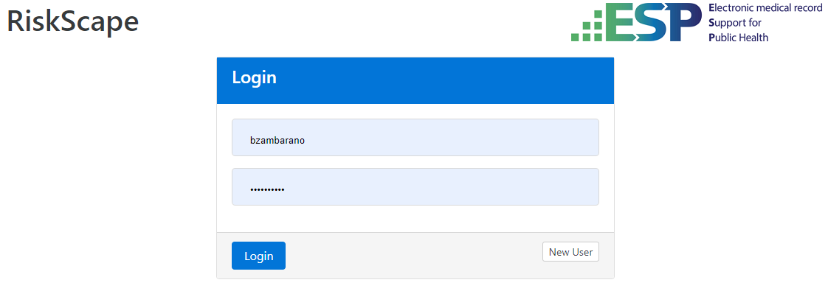
Site-specific SSO opens like so:
The SSO link will open a site-specific SSO login window where you will enter your SSO credentials.

The RiskScape dashboard
Once logged in, your browser will open onto the RiskScape dashboard:
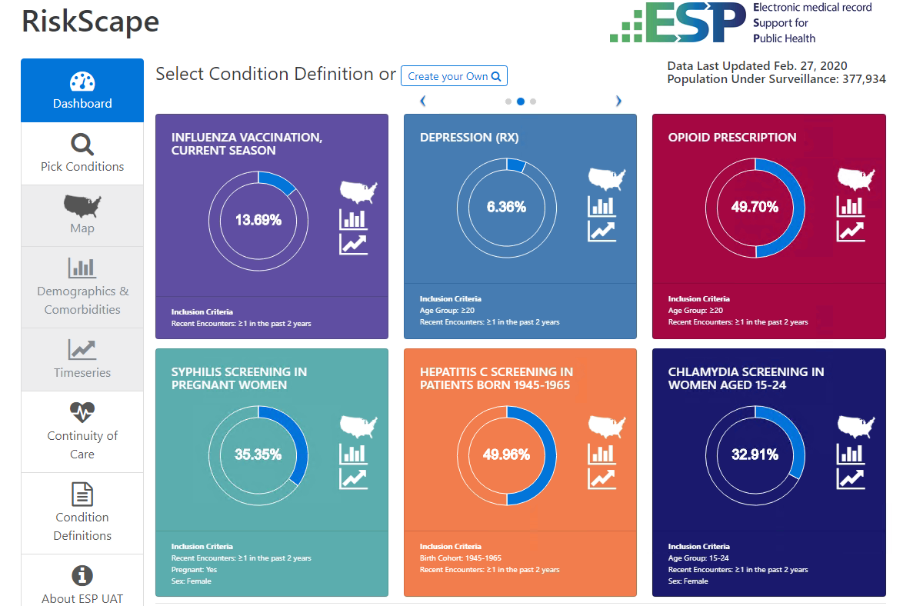
There are several dashboard features to note:

Carousel and pre-defined analyses
The carousel displays six pre-configured analyses panels per page. There are left and right pointing arrows just above the carousel to let you move to two additional pages, for a total of 18 pre-configured analyses.
For each of the analysis panel, the three right-side icons open either a Map showing the geographical distribution of the condition prevalence, bar charts of condition prevalence by configurable stratifiers, or a line chart of prevalence over time.
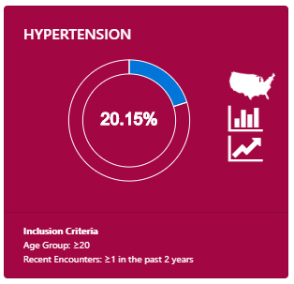
Each panel includes a prevalence "doughnut" showing the current overall prevalence for the disease condition in the ESP population. The inclusion criteria for population is specified at the bottom.

Notes about last updated and population under surveillance
On the right and just above the panel carousel is a note that describes the current ESP data as provisioned to RiskScape:
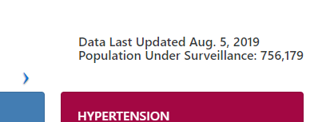
You have the last date when ESP data was loaded, and the count of patient under surveillance. Keep in mind that this is the total count of available patients. Most configured analyses will use selection criteria that will utilize only a subset of the available patients.

Left side nav and links to documents
On the left side of the page (and on every RiskScape page), is the navigation side-bar.
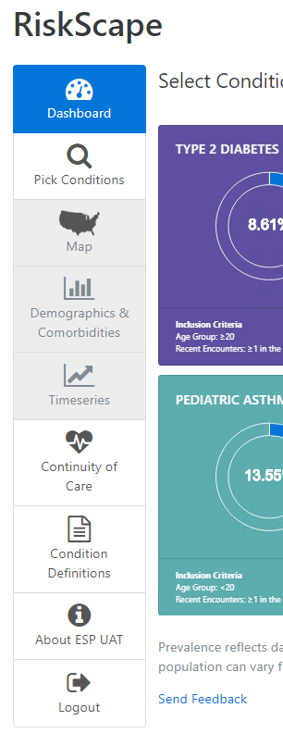 | The left side navigation allows you to move to different analysis displays, to get basic information about the system, or logout. Your current page location is show with a blue background.  If a navigation option is not available, the option is show with a grey background. The Map, Demographics and Timeseries links are grey in this case because no analysis has been chosen or configured yet.  We will review each of the available navigation options further along in the document.  The "Send Feedback" link at the bottom is site-configurable, both as to the text displayed, and what the link does. "Send Feedback" may be a link to form to provide information about an issue you note with the interface or the data – when submitted, the form is sent to the site administrative staff. The link could say "Get Help" and may be a link to form for a help request. The exact working and action of this link is up to your site managers.

Create your own (or Pick Conditions)
At the top of the Carousel is the link "Create your own":
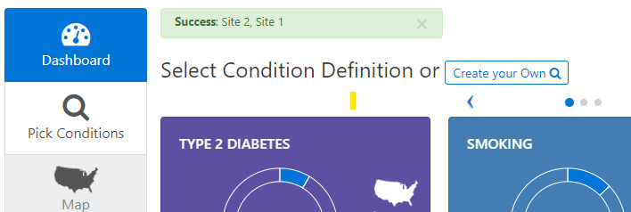
This is the same as the left-side navigation choice "Pick Conditions". This links you to the analysis specification interface, which will be described further on in the document.

The Disease Prevalence Map
If you select a condition, (or create your own analysis), you will be able to view a map showing the geographical distribution of that condition for the region covered by your ESP site(s). Either click on the map icon in the carousel panel, or select the Map navigation link on the left side navigation bar.
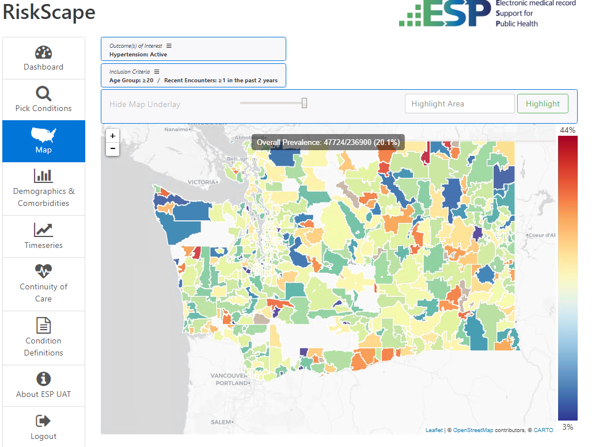
Map regions are color coded according to the heat index on the right: blue for low prevalence, red for high prevalence. The specific color range is constant, but the prevalence range will depend on the condition you have selected. The overall prevalence for the entire region is provided at the top of the map, along with numerator and denominator patient counts.

Map Controls
There are several controls to note:
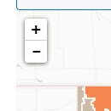 | The plus-minus control on the upper left corner of the map lets you zoom in and out.
The "Hide Map Underlay" slide bar lets you control the opacity of the map to see the Underlay. | 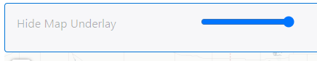
If you know a geocode region ID (zip code), you can enter the value to highlight that location. | 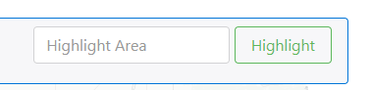
If you click on any of the geocode regions displayed on the map, you will bring up a data display for that region:
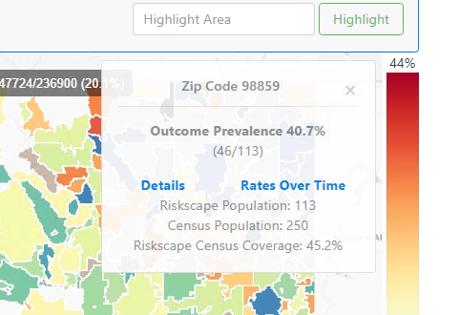

Outcomes and Inclusions Criteria
There are two additional Map controls that are shared across a number of other display pages: The Outcome of Interest and Inclusion Criteria. These controls allow you to modify the definition of the outcome of interest, or modify the population inclusion criteria.
For Outcomes, you can modify the specific condition of interest, and use the "And…" drop-down to pick co-occurring conditions. In this way you can define fairly complex disease conditions for analyisis.
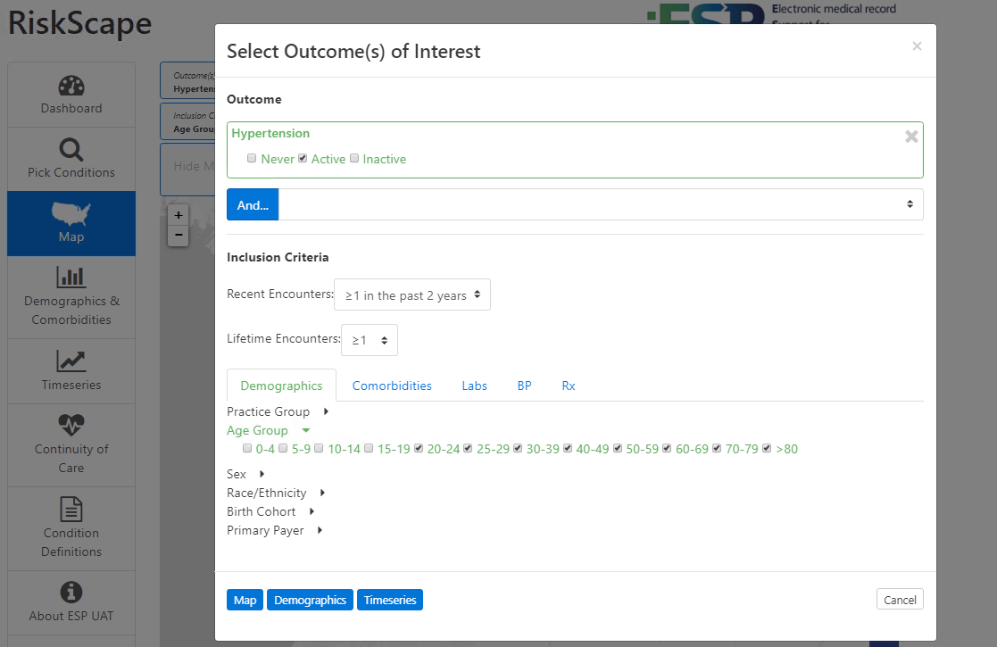
Similarly, the Inclusion criteria can be modified to specify criteria using all available demographic variables and outcome indicators.

Demographics & Comorbidities
The Demographics and Comorbidities page displays a prevalence distribution bar chart by selected stratifiers, and a pie chart of outcome proportions by the selected stratifier.
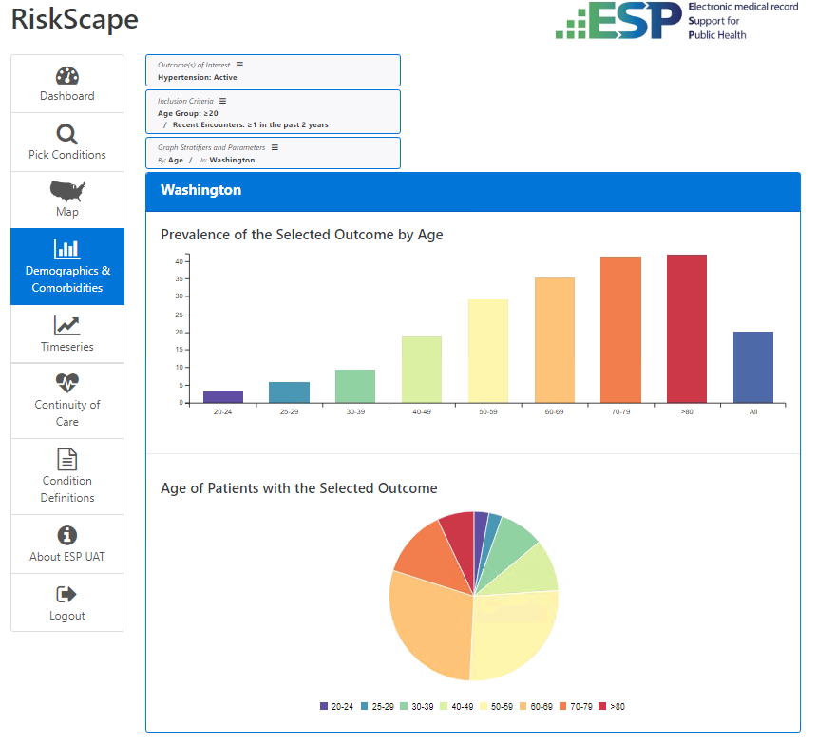

Prevalence Bar Chart
Keep in mind that the prevalence bars do not sum to 100. Prevalence is the percent of the population for each stratifier level that has the condition of interest. At each level, prevalence can vary between 0 and 100%. Clicking on any bar will show details of the prevalence for that group:
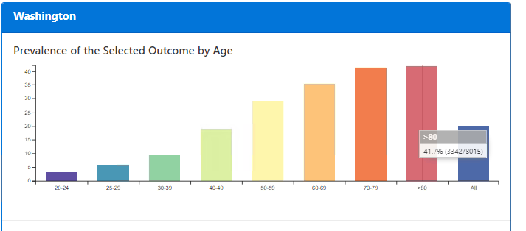

Proportion Pie Chart
The pie chart represents the sub-population of people with the condition of interest. Of all the people with the condition, it shows the relative proportion of people at each stratifier level. Similarly, clicking on a pie portion shows the details for that group:
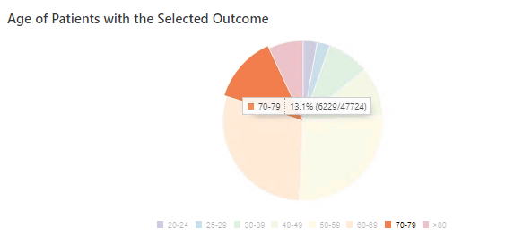

Chart Controls
The controls for Outcomes of Interest and Inclusion Criteria at the top of the page are the same as for the Map.
The additional control for Graph Stratifiers and Parameters provides the ability to select or change stratifiers. Here is the data broken out by gender:
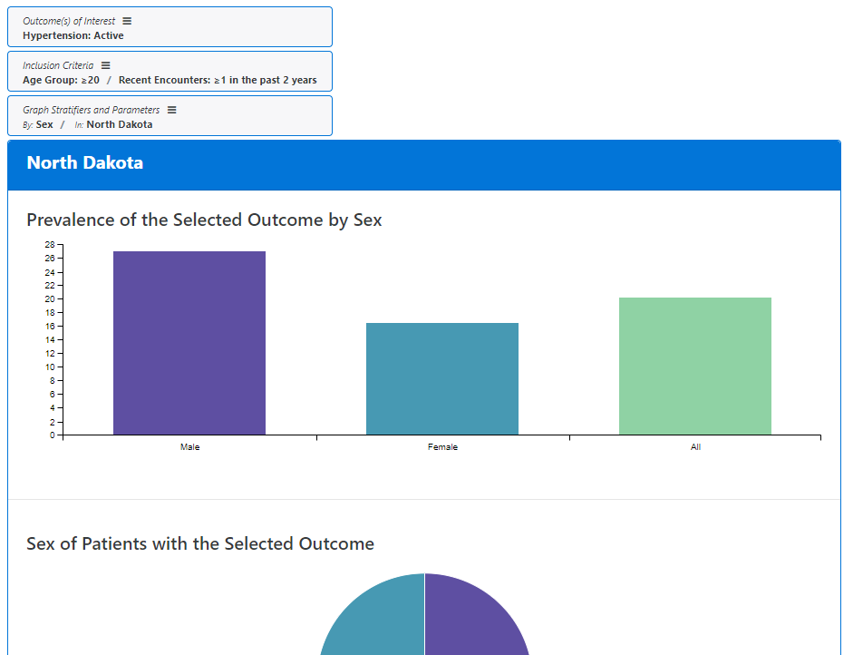

Location Comparision
You can also select a comparison location if desired.
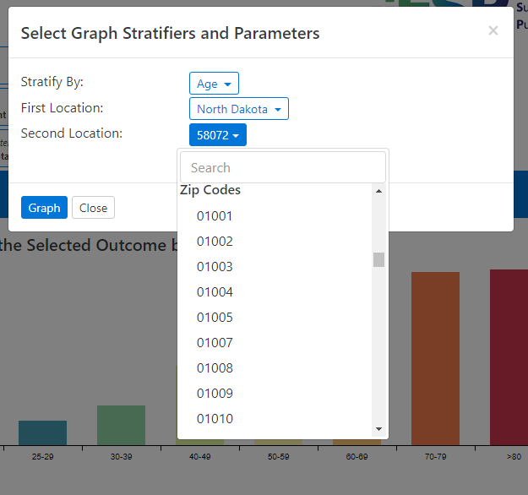
The comparison shows the same plots, side-by-side:
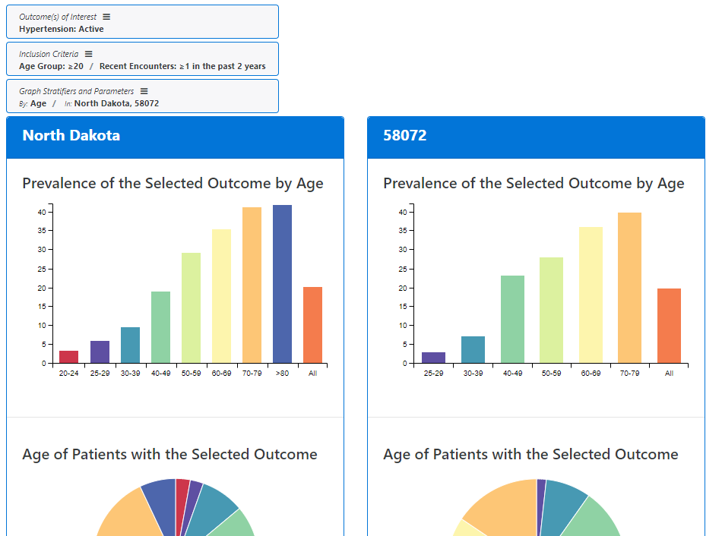

Timeseries Charts
The timeseries charts show condition prevalence across time
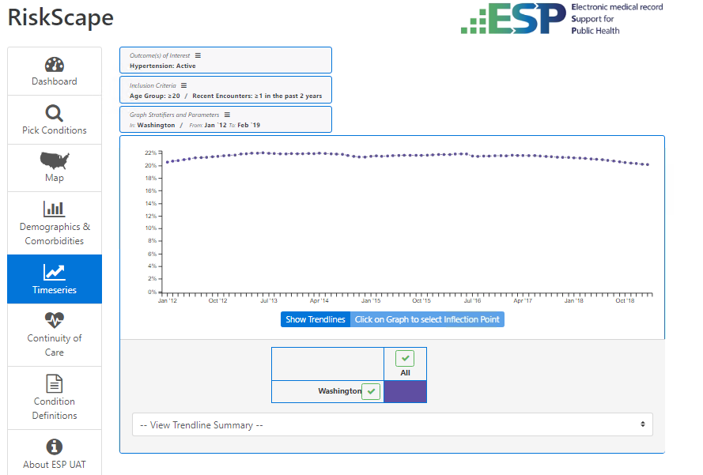
The same controls on the top left are available as for the, but when you add stratifiers or comparison groups, the line-color key at the bottom enables hiding and showing of specific group lines:
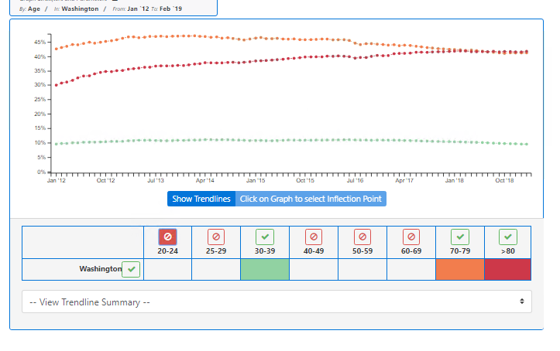

Continuity of Care tabulations
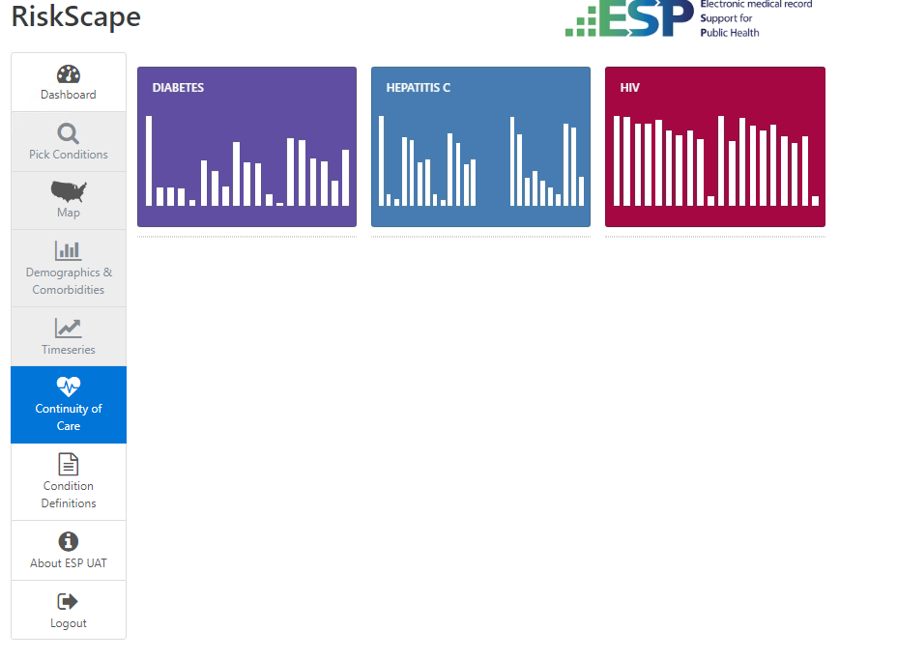
The opening page for the Continuity of Care tabulations presents a similar set of analysis panels as the Dashboard carousel, but these have only a single display for each. You select an analysis by clicking on a panel.

The tabulation
The display shows a tabulation of patient data, starting with a population of patients with a condition of interest. For these patients, subsets are defined meeting specific care criteria. The rows present counts and percentages.
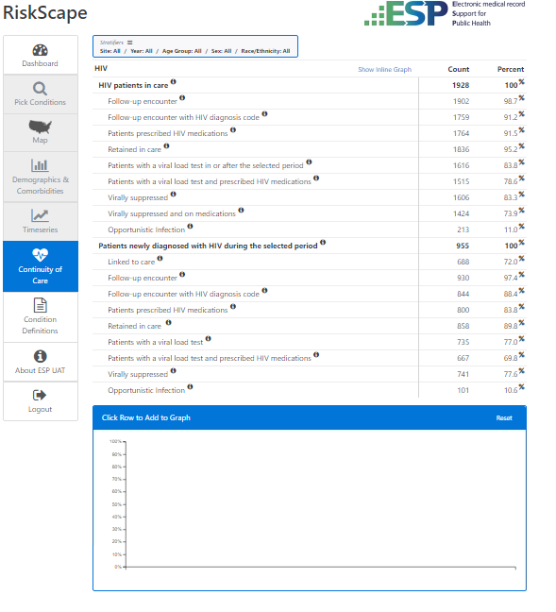

Stratifier controls
The table controls for stratifies are considerably different than for the other Map, Bar Charts or Timeseries. For Continuity of care you are presented with options to include or exclude a specific subset of demographic and year stratifies.
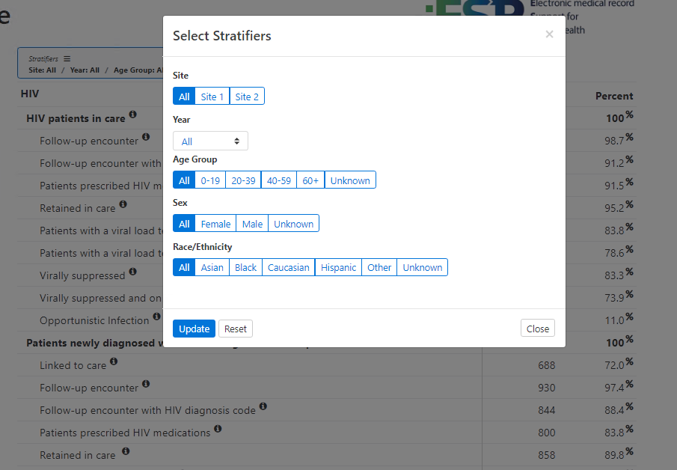

Mouse-over and numerator/denominator identification
As you mouse-over specific rows, an indicator identifies the rows that represent the numerator and denominator for a given row's percentage calculation.
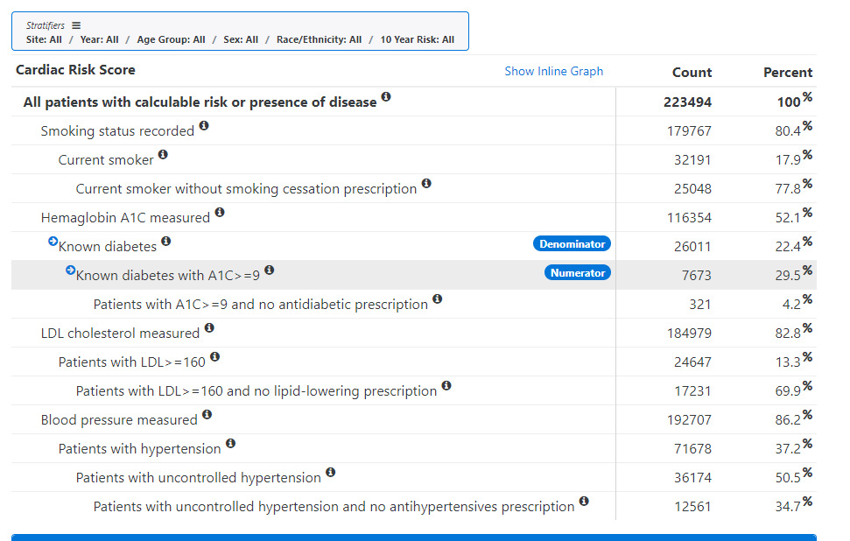

Custom bar chart
By clicking on table rows, you can build a bar chart. The row with the largest patient count select becomes the denominator, while the remaining rows are presented as bars representing percentages of that count.
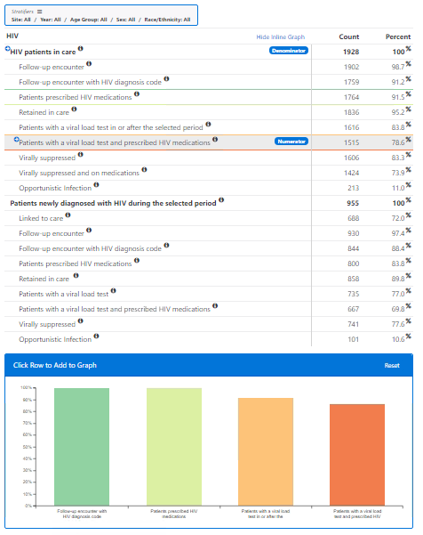

Create your own Analysis
On the left side navigation there is a link to "Pick Conditions", and from the Dashboard there is a link to "Create your own". Both of these open a dialog to Select outcomes of interest and inclusion criteria. This dialog is the same as provided as page-top controls for Maps, Bar Charts and Timeseries pages. You simply select the outcome you are interested in and the inclusion criteria, and then click on one of the links at the page bottom to generate a Map, Demographic charts, or Timeseries page. Once the page chart is generated, you may select stratifiers or comparison locations using the standard controls.
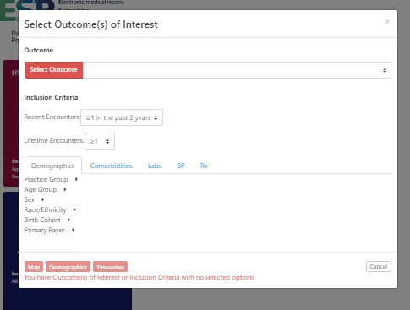

Condition Definitions
The Condition Definitions link on the left side navigation opens a small dialog with links to download disease condition definitions, and the RiskScape data model definition.
