ESP VAERS

Clinical Guide for Practice Managers and Clinicians

Table of Contents

|  |  |
| --- | --- |
| I. Background | 2 |
|  |  |
| A. Vaccine adverse events and the Vaccine Adverse Event Reporting System (VAERS) | 2 |
|  |  |
| B. Automated adverse event surveillance and reporting via the ESP-VAERS system | 2 |
|  |  |
| C. Adverse events that should be reported to VAERS | 3 |
|  |  |
| II. Completing the VAERS report using ESP-VAERS | 3 |
|  |  |
| III. Frequently asked questions | 6 |
|  |  |
| IV. References | 8 |
|  |  |
| V. Appendix: Vaccine Adverse Event Reporting System (VAERS) reporting form | 10 |

**I. Background**

**A. Vaccine adverse events and the Vaccine Adverse Event Reporting System (VAERS)**

Vaccines’ widespread use, their importance to public health, and the well-recognized limitations of pre-approval trials make it imperative to create and maintain robust safety surveillance systems to continually detect and characterize vaccine-associated adverse events. The Centers for Disease Control and Prevention (CDC) and the Food and Drug Administration (FDA) jointly operate the Vaccine Adverse Event Reporting System (VAERS) to facilitate vaccine safety surveillance. VAERS is a passive reporting system that depends upon clinicians and patients to spontaneously recognize possible adverse events and take the initiative to report them. There are few incentives for busy clinicians to do so and no widespread, automated mechanisms to assure complete detection and electronic reporting of adverse events to VAERS. Consequently, the utility of VAERS data is diminished by substantial under-reporting [1]. CDC estimates that fewer than 5% of severe events, such as idiopathic thrombocytopenia after measles-mumps-rubella vaccine or hypotonic-hyporesponsive episodes after diphtheria-tetanus-pertussis vaccine, are reported [2]. Of the reports that *are* sent to VAERS, many are poorly documented, particularly with regard to vaccine lot number and the precise date of administration.

**B. Automated adverse event surveillance and reporting via the ESP-VAERS system**

Electronic health record (EHR) systems such as EPIC offer an opportunity to improve adverse event detection and reporting by automatically scanning EHR data for potential vaccine-associated adverse events and eliciting clinical impressions and comments from providers when the EHR record suggests a possible vaccine-associated adverse effect.

[Insert your local clinical practice name here] is pleased to be implementing an EHR-based system that can alert clinicians to possible vaccine adverse events, elicit clinician feedback, and automatically submit electronic case reports to VAERS. Our vaccine adverse event detection system leverages the Electronic medical record Support for Public Health (ESP) system. ESP is a sophisticated, open-source, EHR-based public health surveillance platform (esphealth.org) [3-5]. ESP-VAERS uses algorithms to survey patients’ diagnoses, laboratory test results, new allergies, and new prescriptions for up to 42 days following vaccination to detect new diagnoses or conditions that may be attributable to a vaccine. If ESP-VAERS detects a suggestive new diagnosis, change in labs, prescription, or new vaccine allergy, ESP-VAERS will notify the clinician diagnosing the event and invite him/her to comment upon and confirm or refute the purported event.

A prototype of the current ESP-VAERS system was piloted at MetroHealth in Ohio in 2012-2013. The reporting rate increased 30-fold during the implementation period compared with prior to implementation. Of clinicians responding to the notifications of potential vaccine adverse events, 55% found the messages helpful and not disruptive to workflow, and 79% considered the number of messages to be appropriate. The pilot demonstrated that automating vaccine-associated adverse event detection, engaging clinicians within their existing workflows to comment on events, and secure reporting to CDC/FDA’s VAERS program were feasible in an EPIC EHR environment [5].

**C. Adverse events that should be reported to VAERS**

Healthcare providers, as well as patients and parents, are asked to report to VAERS any adverse event that occurs after vaccination. As stated by VAERS,

*“You should report any adverse event that happens after getting a vaccine, even if you are not sure that the vaccine caused the adverse event. It is especially important to report any adverse event that resulted in hospitalization, disability, or death.”*

**II. Completing the VAERS report using ESP-VAERS**

If a possible vaccine-associated adverse event occurring within 42 days of vaccination is detected via the ESP VAERS algorithms, an automated message will go to the in-basket of the clinician who diagnosed the condition. The message will provide summary information about the patient’s potential adverse event, along with the immunization and triggering event. This document becomes part of the patient’s medical record. The message will include a web link back to the ESP system. If you click on the link in the message, a screen like the following appears:

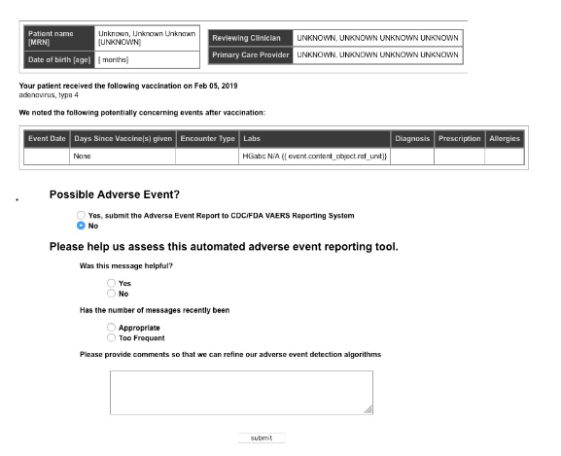

If, as in this example, you answer “No” to “Possible Adverse Event?,” then no further action is needed, although you have the option of answering three brief questions to help your local ESP VAERS promoters evaluate whether the system is useful and acceptable to you and other clinicians.

If you answer “Yes” to “Possible Adverse Event?,” then a few additional important pieces of information are solicited, as shown in this screen:

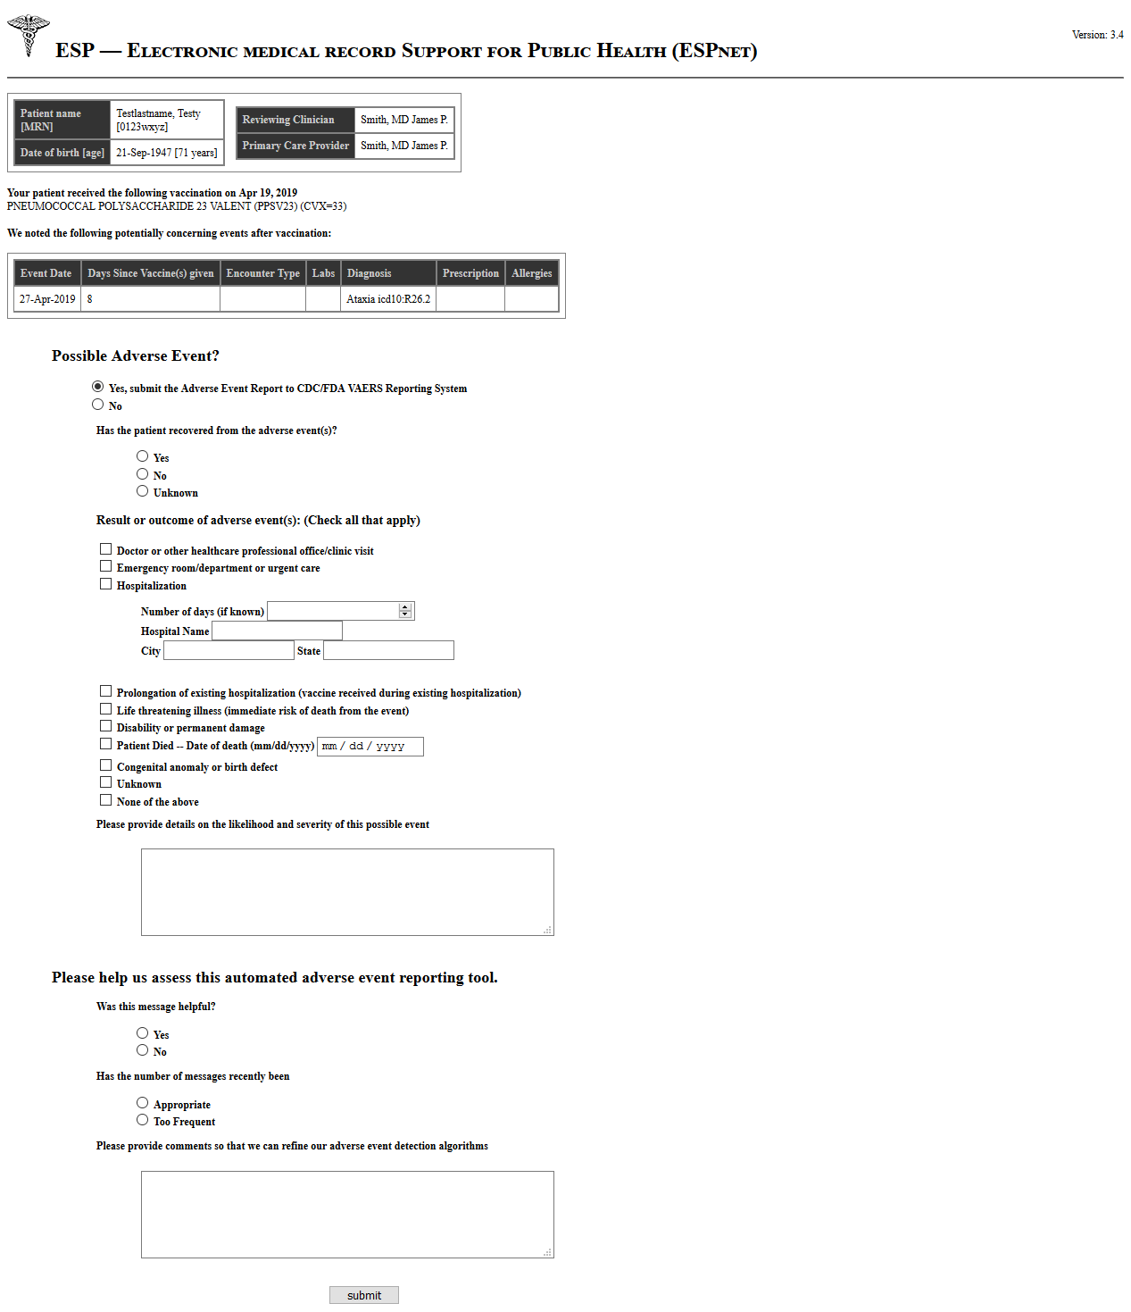

This additional information about the adverse event is incorporated into an online VAERS form (see full form in appendix), the rest of which is filled out automatically. You then click on “Submit” to send the form to VAERS. A notice that a VAERS report was sent via ESP VAERS (but not the filled-out form itself) is placed in your patient’s record, including reference to the specific vaccination(s) and the triggering event.

If you do not electronically comment on the event within 7 days, what happens next depends on the nature of the adverse event. In the case of *rare, serious, known adverse events* or *adverse events considered to be likely associated with vaccination*, reports will automatically go to VAERS. In the case of *possible adverse events*, no automatic reports will go to VAERS—you must explicitly confirm that such an event might be vaccine-associated in order for a report to VAERS to be generated.

These scenarios are presented graphically in the figure below:

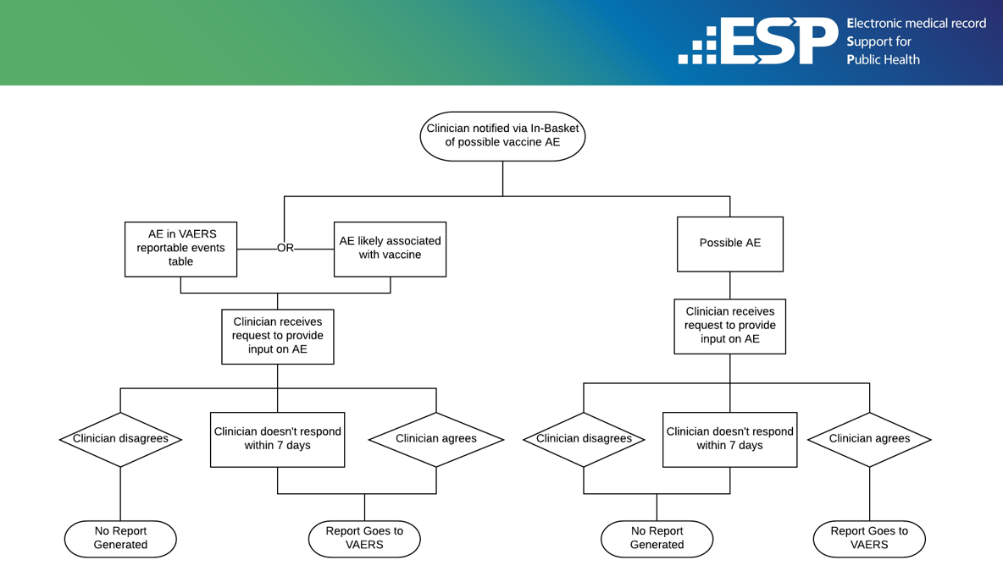

**III. Frequently asked questions**

1. What is VAERS and how can I find out more about it?

VAERS is the national Vaccine Adverse Event Reporting System maintained by the CDC and FDA to receive spontaneous reports of adverse events after vaccination with U.S. licensed vaccines. Monitoring and analysis of these reports allows safety problems to be detected. An article by Shimabukuro et al. [6] sums up the history of VAERS and its relationship to the National Childhood Vaccine Injury Act as follows:

*“VAERS was established in 1990 [*[*7*](https://www.ncbi.nlm.nih.gov/pmc/articles/PMC4632204/#R17)*,*[*8*](https://www.ncbi.nlm.nih.gov/pmc/articles/PMC4632204/#R18)*] to fulfill a requirement of the National Childhood Vaccine Injury Act of 1986 [*[*9*](https://www.ncbi.nlm.nih.gov/pmc/articles/PMC4632204/#R19)*]. By law, vaccine manufacturers are required to report adverse events that come to their attention, and healthcare professionals are required to report adverse events that are considered a contraindication to further doses of vaccine and those specified in the VAERS Table of Reportable Events Following Vaccination [*[*10*](https://www.ncbi.nlm.nih.gov/pmc/articles/PMC4632204/#R20)*-*[*13*](https://www.ncbi.nlm.nih.gov/pmc/articles/PMC4632204/#R23)*]. The National Childhood Vaccine Injury Act of 1986 also authorized establishment of the National Vaccine Injury Compensation Program [*[*14*](https://www.ncbi.nlm.nih.gov/pmc/articles/PMC4632204/#R24)*]. Adverse events on the VAERS Table of Reportable Events Following Vaccination mirror the “illness, disability, injury or condition covered” conditions in the National Vaccine Injury Compensation Program’s Vaccine Injury Table [*[*15*](https://www.ncbi.nlm.nih.gov/pmc/articles/PMC4632204/#R25)*] used to help adjudicate petitioner claims of vaccine related injury.”*

Resources:

VAERS website:

[https://vaers.hhs.gov/](https://nam03.safelinks.protection.outlook.com/?url=https%3A%2F%2Fvaers.hhs.gov%2F&data=02%7C01%7Ckatherine_yih%40harvardpilgrim.org%7C199a1c75be294734787808d6cfec0754%7Cc8aa38aae6c04e14a713ac811f76b6b4%7C0%7C0%7C636925009993534967&sdata=k3m2ydDd0eBKdjThUM%2BOdgr2hM6UQXJh8qLWjnIe%2FbI%3D&reserved=0)

CDC website on VAERS: [https://www.cdc.gov/vaccinesafety/ensuringsafety/monitoring/vaers/index.html](https://nam03.safelinks.protection.outlook.com/?url=https%3A%2F%2Fwww.cdc.gov%2Fvaccinesafety%2Fensuringsafety%2Fmonitoring%2Fvaers%2Findex.html&data=02%7C01%7Ckatherine_yih%40harvardpilgrim.org%7C199a1c75be294734787808d6cfec0754%7Cc8aa38aae6c04e14a713ac811f76b6b4%7C0%7C0%7C636925009993544979&sdata=knm5NeyT4ZqMPpsGQ4%2B0fsK2jQ1pS5Ot1m19hcF75lo%3D&reserved=0)

VAERS Table of Reportable Events:

[https://vaers.hhs.gov/docs/VAERS_Table_of_Reportable_Events_Following_Vaccination.pdf](https://nam03.safelinks.protection.outlook.com/?url=https%3A%2F%2Fvaers.hhs.gov%2Fdocs%2FVAERS_Table_of_Reportable_Events_Following_Vaccination.pdf&data=02%7C01%7Ckatherine_yih%40harvardpilgrim.org%7C199a1c75be294734787808d6cfec0754%7Cc8aa38aae6c04e14a713ac811f76b6b4%7C0%7C0%7C636925009993544979&sdata=SabYi180kTUqi5z8T%2FTBHprEFe1skPa7EWm0eUEFTFA%3D&reserved=0)

Shimabukuro TT, Nguyen M, Martin D, et al. Safety monitoring in the Vaccine Adverse Event Reporting System (VAERS). Vaccine. 2015;33(36):4398–4405:

<https://www.ncbi.nlm.nih.gov/pmc/articles/PMC4632204/>

1. Why do I need to report possible vaccine adverse events to VAERS?

Pre-licensure clinical trials are not conducted in large or diverse enough study populations to detect very rare true adverse effects of vaccination. Reporting of possible vaccine-associated adverse events to VAERS is one of the most important ways by which previously unknown adverse effects of vaccination come to the attention of public health authorities after new vaccines are licensed. Analysis of VAERS reports can also help identify risk factors for certain kinds of adverse effects and batch- or lot-specific safety problems. Under-reporting of adverse events to VAERS reduces its power and utility for identifying safety problems.

Clinically important and unexpected adverse events, especially, should be reported, even if one is not sure they were caused by vaccination.

1. What happens when the ESP-VAERS system detects a potential vaccine adverse event?

A message goes to the in-basket of the clinician who diagnosed the health event. It will be similar in format to this one:

*Dear Dr. JONES*

*Your patient Sam Adams may have suffered an adverse effect from a recent vaccine. Sam Adams was diagnosed with MENINGITIS on AUGUST 12 2019, 7 days after receiving MEASLES VACCINE. If you think the MENINGITIS might have been due to the vaccine, we can automatically submit an electronic report to CDC / FDA’s Vaccine Adverse Event Reporting System on your behalf.*

There will be a web link (URL) in the message. When you click on this, an input screen will open. If you think that the adverse event in question *might* be a vaccine adverse event, you select “Yes” in the input screen, which will open another screen with a few more questions to answer. The report will then go to VAERS without your having had to fill in all the fields manually.

1. What if I do not believe that this health care event was related to vaccination?

In such a case, you should answer “No” to the question of whether you think the event is a possible vaccine-associated adverse event. No report to VAERS will be generated if you click “No” within 7 days of receipt of the message.

1. What happens if I don’t respond to or even look at a possible vaccine adverse event message from ESP-VAERS?

It depends on the nature of the adverse event. If it is rare, serious, and/or considered likely to be associated with vaccination and you do not respond to the message within 7 days, a report will automatically be sent to VAERS. Otherwise, no report will be sent.

1. Under what circumstances does information about a possible vaccine-associated adverse event detected by ESP VAERS go into my patient’s chart?

Whenever the ESP VAERS algorithms detect a possible vaccine adverse event, a note about the immunization and the triggering event goes into your patient’s chart. The note remains in the medical record regardless of whether or how you respond to it.

1. What if I or another health care professional or the patient already reported the adverse event to VAERS?

There is no problem with multiple reports of an event being sent to VAERS. VAERS analysts can sort out the duplicates.

1. What is the reporting impact of ESP-VAERS?

During the pilot study of ESP-VAERS at MetroHealth, the reporting rate increased 30-fold [3]. A largely automated reporting system like ESP-VAERS has the potential to substantially reduce the problem of under-reporting to VAERS if implemented on a large scale.

**IV. References**

[1] Chen RT, Davis RL, Rhodes PH. Special methodological issues in pharmacoepidemiology studies of vaccine safety. In: Strom BL, ed. *Pharmacoepidemiology*. 4th ed. Chichester ; Hoboken, NJ: J. Wiley; 2005:455-485.

[2] Rosenthal S, Chen R. The reporting sensitivities of two passive surveillance systems for vaccine adverse events. *American Journal of Public Health.* 1995;85(12):1706-1709.

[3] Baker MA, Kaelber DC, Bar-Shain DS, Moro PL, Zambarano B, Mazza M, Garcia C, Henry A, Platt R, Klompas M. Advanced clinical decision support for vaccine adverse event detection and reporting. Clinical Infectious Diseases, 2015;61(6):864–870. Available at:

<https://academic.oup.com/cid/article/61/6/864/451758>

[4] Automated detection and reporting of notifiable diseases using electronic medical records versus passive surveillance--massachusetts, June 2006-July 2007. *MMWR Morb Mortal Wkly Rep.* 2008;57(14):373-376.

[5] Lazarus R, Klompas M, Campion FX, McNabb SJ, Hou X, Daniel J, Haney G, DeMaria A, Lenert L, Platt R. Electronic Support for Public Health: validated case finding and reporting for notifiable diseases using electronic medical data. *Journal of the American Medical Informatics Association: JAMIA.* 2009;16(1):18-24.

[6] Shimabukuro TT, Nguyen M, Martin D, et al. Safety monitoring in the Vaccine Adverse Event Reporting System (VAERS). *Vaccine*. 2015;33(36):4398–4405. Available at:

<https://www.ncbi.nlm.nih.gov/pmc/articles/PMC4632204/>

[7] Centers for Disease Control and Prevention Vaccine Adverse Event Reporting System–United States. MMWR Morb Mortal Wkly Rep. 1990;39(41):730–733. [[PubMed](https://www.ncbi.nlm.nih.gov/pubmed/2120567)] [[Google Scholar](https://scholar.google.com/scholar_lookup?journal=MMWR+Morb+Mortal+Wkly+Rep&title=Vaccine+Adverse+Event+Reporting+System–United+States&volume=39&issue=41&publication_year=1990&pages=730-3&pmid=2120567&)]

[8] Chen RT, Rastogi SC, Mullen JR, Hayes SW, Cochi SL, Donlon JA, Wassilak SG. The Vaccine Adverse Event Reporting System (VAERS) Vaccine. 1994;12(6):542–550. [[PubMed](https://www.ncbi.nlm.nih.gov/pubmed/8036829)] [[Google Scholar](https://scholar.google.com/scholar_lookup?journal=Vaccine&title=The+Vaccine+Adverse+Event+Reporting+System+(VAERS)&author=RT+Chen&author=SC+Rastogi&author=JR+Mullen&author=SW+Hayes&author=SL+Cochi&volume=12&issue=6&publication_year=1994&pages=542-50&pmid=8036829&)]

[9] 42 U.S. Code §§ 300aa-1 to 300aa-34. National Childhood Vaccine Injury Act (1986).

[10] What can be reported to VAERS? Available at: <https://vaers.hhs.gov/about/faqs#what>. Accessed June 5, 2015.

[11] U.S. Code of Federal Regulations, 21 CFR 600.80 Postmarketing reporting of adverse experiences. 2014 Available at: <http://www.accessdata.fda.gov/scripts/cdrh/cfdocs/cfcfr/cfrsearch.cfm?fr=600.80>. Accessed June 5, 2015.

[12] Recording and Reporting of Information. 1999 42 U.S. Code § 300aa-25. Available at: <http://www.fda.gov/RegulatoryInformation/Legislation/ucm180189.htm>. Accessed June 5, 2015.

[13] VAERS Table of Reportable Events Following Vaccination. Available at: <https://vaers.hhs.gov/resources/VAERS_Table_of_Reportable_Events_Following_Vaccination.pdf>. Accessed June 5, 2015.

[14] Cook KM, Evans G. The National Vaccine Injury Compensation Program. Pediatrics. 2011 May;127(Suppl 1):S74–77. [[PubMed](https://www.ncbi.nlm.nih.gov/pubmed/21502255)] [[Google Scholar](https://scholar.google.com/scholar_lookup?journal=Pediatrics&title=The+National+Vaccine+Injury+Compensation+Program&author=KM+Cook&author=G+Evans&volume=127&issue=Suppl+1&publication_year=2011&pages=S74-7&pmid=21502255&)]

[15] Vaccine injury table. Available at: <http://www.hrsa.gov/vaccinecompensation/vaccineinjurytable.pdf>. Accessed June 5, 2015.

**V. Appendix: Vaccine Adverse Event Reporting System (VAERS) reporting form**

