VAERS 2.0 HL7 2.3.1 Messaging
Technical Documentation

Revision History
Version Number | Modification Date |  | By |  | Description of Changes
1.0 | 25 Mar 2019 | C. Wright |  | Initial version

Contents
1 Overview 4
2 Background 4
3 Changes from VAERS 1.0 to 2.0 4
3.1 Removed fields 4
3.2 Renamed/altered fields 4
3.3 Newly added fields 5
4 Extensions to the Version 2.3.1 HL7 Standard 5
5 Example HL7 message 6
Appendix A – VAERS 2.0 Form 9

Overview
VAERS 1.0 HL7 messaging was based on the “Implementation Guide for Immunization Data Transactions using Version 2.3.1 of the Health Level Seven (HL7) Standard Protocol”, version 2.2, dated June 2006. This document describes the methods of extending the 2.3.1 version HL7 standard to meet the needs of VAERS Phase 2 reporting. It provides descriptions of the message’s purpose and structure, the changes made from the VAERS 1.0 form to the new VAERS 2.0 form, and the extensions that were made.
An example VAERS 2.0 HL7 message is provided in section 5 to demonstrate the structure and format of the transmitted data, as it relates to the VAERS 2.0 form.

Background
VAERS reporting uses the “Unsolicited Transmission of an Observation (ORU)” message format as described on page 13 of the Implementation Guide. This message format uses a three-level hierarchy to describe a clinical report. The Patient Identification (PID) segment at the top level, followed by Order Record (OBR) segments at the next level, each of which may contain one or more Observation Reports (OBX) segments at the third level.
None of the ORU message format’s optional segments (PD1, PV1, PV2, CTI, and DSC) are included in a VAERS message.

Changes from VAERS 1.0 to 2.0
There are several differences between the version 1.0 and 2.0 VAERS forms. The changes include removals of some data fields, renaming of others, and the addition of quite a few more fields. Where possible, additional information about the field or the sections they belong to have been added in brackets to increase clarity.
These field changes affect the “essential” set of fields to be completed. VAERS 2.0 Questions 2, 3, 4, 5, 6, 17, 18 and 21 are currently essential fields to complete.

Removed fields
- Q2. County where administered
- Q16. Vaccine purchased with [type of funds]
- Q20. Have you reported this adverse event previously?
[Only for children 5 and under]
- Q22. Birth weight
- Q23. No. of brothers and sisters
[Only for reports submitted by manufacturer/immunization project]
- Q25. Date received by mfr./imm.proj
- Q26. 15 day report? [Yes,No]
- Q27. Report type

Renamed/altered fields
There are a few minor alterations to the constitution or name of previous fields. The single text box for age at time of vaccination, which could have been years or months (if less than a year old), are now two separate fields, one each for years and months.

One other field was effectively renamed from VAERS 1.0. “Vaccine administered by” is now “Best doctor/healthcare professional to contact about the adverse event” (Q14).

Newly added fields
- Use the space below to provide any additional information (indicate item number) [Unnumbered text box at the end of the form]
- Q8. Pregnant at time of vaccination? [Yes, No, Unknown]
- Q24. Race
- Q25. Ethnicity
[Complete only for U.S. Military/Department of Defense (DoD) related reports]
- Q27. Status at vaccination [Active Duty, Reserve, National Guard, Beneficiary, Other: <Textbox>]
- Q28. Vaccinated at Military/DoD site? [Yes, No]

Extensions to the Version 2.3.1 HL7 Standard
Our extensions to the standard revolve around the use of additional OBX data segments and the use of local codes to identify data points that do not have corresponding LOINC codes. The use of local codes instead of LOINC is allowed in OBX segments, using the OBX-3 format, ^^^LocalCode^LocalCodeDecription^L.
Except for a few new or renamed fields that corresponded to an existing segment, like Race and Ethnicity falling under the PID segment, an OBX segment is used to transmit data. The following fields use Observation record (OBX) segments to convey their values:
OBX-3 Local Code | OBX-3 LC Description | VAERS field
YEAR AGE | Age at vaccination year | Q6 Age at vaccination > Years
MONTH AGE | Age at vaccination month | Q6 Age at vaccination > Months
PREGNANT | Pregnant at time of vaccination | Q8 Pregnant at time of vaccination
POC | Best Healthcare Professional to Contact | Q14 Best doctor/healthcare professional to contact about the adverse event
VAX AT OTHER | Vaccinated At Other | Q16 Vaccinated at > Other
ALLERGIES | Allergies | Q10 Allergies to medications, food, or other products:
HOSPNAME | Hospital Name | Q21 Hospital Name
HOSPCITY | Hospital City | Q21 City
HOSPSTATE | Hospital State | Q21 State
PREVAE | Adverse event following any previous vaccine | Q23 Adverse event following any previous vaccine
PREVAETEXT | Adverse event following any previous vaccine Text | Q23 Adverse event following any previous vaccine Text
MILSTATA | Active Duty | Q27 Status at vaccination > Active Duty
MILSTATR | Reserve | Q27 Status at vaccination > Reserve
MILSTATN | National Guard | Q27 Status at vaccination > National Guard
MILSTATB | Beneficiary | Q27 Status at vaccination > Beneficiary
MILSTATO | Other Military Status | Q27 Status at vaccination > Other Military Status
MILSTATOTEXT | Other Military Status Text | Q27 Status at vaccination > Other Military Status Text
DODSITE | Vaccinated at Military/DoD site | Q28 Vaccinated at DoD site
The new VAERS 2.0 message continues to the use existing three-tier ORU message format. Additionally, no changes or updates have been made to the use of the code tables in Appendix 1 of the Implementation Guide. These tables should continue to be utilized, as is, for all messaging.

Example HL7 message

VAERS  Item  Number | EXAMPLE SEGMENTS THAT ANSWER THE VAERS QUESTIONS | Code Tables To Be Used
 | MSH|^~\&||WrightHealth VAERS vaersapp01|VAERS HL7 Processor|VAERS PROCESSOR|2019012920311548811889||ORU^R01|232|D|2.3.1|||NE|AL|
1,2,3,24,25 | PID|||8675309^^^^MR||Testlastname^Robert^^^^^L||20180811|MALE||W~B|1234 Deadend Dr^Apt A^Anytown^MD^12345^^C||(301) 123-4567^PRN~rtest@example.com^NET|||||||||N|||||||2019012815131548706385|Y | User-defined 001  User-defined 005  User-defined 189
13 | NK1|1|PIERCE^BENJAMIN^^^MD^^L|FOT^Form completed by (Name)-Other^HL70063|WrightHealth Medical Center^2500 WrightHealth Drive^ANYTOWN^MARYLAND^21713^^B|778-2222^WPN~doc@example.com^NET||||||||||||||||| | HL7 063
14 | NK1|2|PIERCE^BENJAMIN^^^MD^^L|POC^Best Healthcare Professional to Contact^HL70063|||778-2222^311^WPN|||||||||||||||||||||||||||||| | HL7 063
15 | ORC|RE|||||||||||151522^Vaxerlast^Dexter^^^RN^^L|||||||||PED COMP CARE|WrightHealth Medical Center^2500 WrightHealth Drive^ANYTOWN^MARYLAND^21713^^B|778-8643^WPN^PH~778-8644^WPN^FX|WrightHealth Medical Center^2500 WrightHealth Drive^ANYTOWN^MARYLAND^21713^^B
 | OBR|1|||CDC VAERS-2 (FDA) Report|||20190130|||||||||||||||||||||||||||||||||||
6 | OBX|1|NM|^^^YEAR AGE^Age at vaccination year^L||0|yr^year^ANSI|||||F|||||| | ANSI unit codes
 | OBX|2|NM|^^^MONTH AGE^Age at vaccination month^L||6|mo^month^ANSI|||||F|||||| | ANSI unit codes
18 | OBX|3|FT|30948-4^Vaccination adverse events and treatment, if any^LN|1|Adverse effect of vaccines and biological substances, init on 2019-01-21, clinician comment: . ||||||F|||||| | NIP003
4 | OBX|4|TS|30952-6^Date of vaccination^LN||20190121||||||F|||||| | NIP003
5 | OBX|5|TS|30953-4^Adverse event onset date and time^LN||20190129||||||F|||||| | NIP003
8 | OBX|6|ST|^^^PREGNANT^Pregnant at time of vaccination^L||No||||||F|||||| | HL7 136
16 | OBX|7|CE|30962-5^Vaccinated at^LN||PVT^Private doctors office/hospital^NIP007||||||F|||||| | NIP007
16 | OBX|8|ST|^^^VAX AT OTHER^Vacinated At Other^L||Other location text||||||F||||||
9 | OBX|9|FT|30964-1^Other medications^LN||None||||||F|||||| | NIP003
19 | OBX|11|FT|30954-2^Relevant diagnostic tests/lab data^LN||None||||||F|||||| | NIP003
20 | OBX|12|FT|30951-8^Patient Recovered^LN||N^No^HL70136||||||F|||||| | NIP003  HL7 0136
10 | OBX|13|FT|^^^ALLERGIES^Allergies^L||Amoxicillian||||||F||||||
11 | OBX|14|FT|30965-8^Illness present at time of vaccination^LN||None||||||F|||||| | NIP003
12 | OBX|15|FT|30966-6^Pre-existing physician-diagnosedallergies, birth defects, medical conditions^LN||None||||||F|||||| | NIP003
21 | OBX|16|FT|30949-2^Vaccination adverse event outcome^LN||E^Doctor or other healthcare professional office/clinic visit^NIP005||||||F|||||| | NIP003  NIP005
 | OBX|17|FT|30949-2^Vaccination adverse event outcome^LN||E^Emergency room or emergency department visit^NIP005||||||F|||||| | NIP003  NIP005
 | OBX|18|FT|30949-2^Vaccination adverse event outcome^LN|3|H^Required hospitalization^NIP005||||||F|||||| | NIP003  NIP005
 | OBX|19|NM|30950-0^Number of days hospitalized due to vaccination adverse event^LN|3|05|d^day^ANSI|||||F|||||| | ANSI unit codes
 | OBX|20|FT|^^^HOSPNAME^Hospital Name^L|3|Meritus Medical Center||||||F||||||
 | OBX|21|FT|^^^HOSPCITY^Hospital City^L|3|Hagerstown||||||F||||||
 | OBX|22|FT|^^^HOSPSTATE^Hospital State^L|3|MD||||||F||||||
 | OBX|23|FT|30949-2^Vaccination adverse event outcome^LN||P^Prolongation of existing hospitalization^NIP005||||||F|||||| | NIP003  NIP005
 | OBX|24|FT|30949-2^Vaccination adverse event outcome^LN||L^Life threatening illness^NIP005||||||F|||||| | NIP003  NIP005
 | OBX|25|FT|30949-2^Vaccination adverse event outcome^LN||J^Resulted in permanent disability^NIP005||||||F|||||| | NIP003  NIP005
 | OBX|26|FT|30949-2^Vaccination adverse event outcome^LN||D^Patient died^NIP005||||||F|||||| | NIP003  NIP005
 | OBX|27|FT|30949-2^Vaccination adverse event outcome^LN||C^Congenital anomaly or birth defect^NIP005||||||F|||||| | NIP003  NIP005
 | OBX|28|FT|30949-2^Vaccination adverse event outcome^LN||O^None of the above^NIP005||||||F|||||| | NIP003  NIP005
23 | OBX|29|NM|^^^PREVAE^Adverse event following any previous vaccine^L||Yes||||||F||||||
 | OBX|30|FT|^^^PREVAETEXT^Adverse event following any previous vaccine Text^L||Patient age: 10, vaccination dates: 19990217, vaccine type and brand name: Wonderdrug Injection||||||F||||||
27 | OBX|31|NM|^^^MILSTATA^Active Duty^L||Yes||||||F||||||
 | OBX|32|NM|^^^MILSTATR^Reserve^L||Yes||||||F||||||
 | OBX|33|NM|^^^MILSTATN^National Guard^L||Yes||||||F||||||
 | OBX|34|NM|^^^MILSTATB^Beneficiary^L||Yes||||||F||||||
 | OBX|35|FT|^^^MILSTATO^Other Military Status^L||Yes||||||F||||||
 | OBX|36|NM|^^^MILSTATOTEXT^Other Military Status Text^L||Yes||||||F||||||
 | OBX|37|NM|^^^DODSITE^Vaccinated at Military/DoD site^L||No||||||F||||||
17 | OBR|2|||30955-9^All vaccines given on date listed in #10^LN|||||||||||||||||||||||||||||||||||||| | NIP003
 | OBX|1|CE|30955-9&30956-7^Vaccine type^LN|1|08^HepB-Adolescent/pediatric^CVX||||||F| | HL7 227
 | OBX|2|CE|30955-9&30957-5^Manufacturer^LN|1|MSD^Merck^MVX||||||F| | HL7 292
 | OBX|3|ST|30955-9&30959-1^Lot number^LN|1|MRK12345||||||F|
 | OBX|4|CE|30955-9&30958-3^Route^LN|1|IM^Intramuscular^HL70162||||||F| | HL7 162
 | OBX|5|CE|30955-9&31034-2^Site^LN|1|LA^Left arm^HL70163||||||F| | HL7 163
 | OBX|6|NM|30955-9&30973-2^Dose number in series^LN|1|01||||||F|
 | OBX|7|CE|30955-9&30956-7^Vaccine type^LN|2|50^DTaP-Hib^CVX||||||F| | HL7 227
 | OBX|8|CE|30955-9&30957-5^Manufacturer^LN|2|WAL^Wyeth-Ayerst^MVX||||||F| | HL7 292
 | OBX|9|ST|30955-9&30959-1^Lot number^LN|2|W46932777||||||F|<CR>
 | OBX|10|CE|30955-9&30958-3^Route^LN|2|IM^Intramuscular^HL70162||||||F| | HL7 162
 | OBX|11|CE|30955-9&31034-2^Site^LN|2|LA^Left arm^HL70163||||||F| | HL7 163
 | OBX|12|NM|30955-9&30973-2^Dose number in series^LN|2|01||||||F|
22 | OBR|3|||30961-7^Any other vaccinations within 4 weeks prior to the date listed in #10^LN|||||||||||||||||||||||||||||||||||||| | NIP003
 | OBX|1|CE|30961-7&30956-7^Vaccine type^LN|1|10^IPV^CVX||||||F| | HL7 227
 | OBX|2|CE|30961-7&30957-5^Manufacturer^LN|1|PMC^Aventis Pasteur^MVX||||||F| | HL7 292
 | OBX|3|ST|30961-7&30959-1^Lot number^LN|1|PMC123456||||||F|
 | OBX|4|CE|30961-7&30958-3^Route^LN|1|SC^Subcutaneaous^HL70162||||||F| | HL7 162
 | OBX|5|CE|30961-7&31034-2^Site^LN|1|LA^Left arm^HL70163||||||F| | HL7 163
 | OBX|6|NM|30961-7&30973-2^Dose number in series^LN|1|01||||||F|
 | OBX|7|TS|30961-7&31035-9^date given^LN|1|20001216||||||F|
26 | OBR|4|||^Only for reports submitted by manufacturer/immunization project||||||||||||||||||||||||||||||||||||||
 | OBX|1|ST|30975-7^Mfr./Imm. Proj. report no.^LN||WRIGHTHEALTHESP2012232||||||F|||||| | NIP003

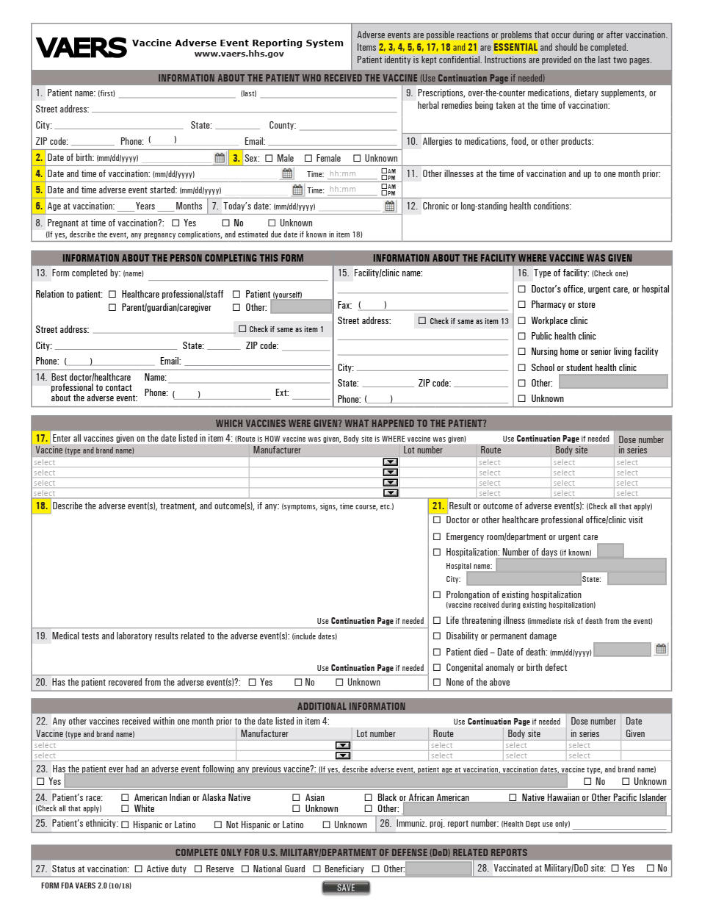
Appendix A – VAERS 2.0 Form
